1)

2) 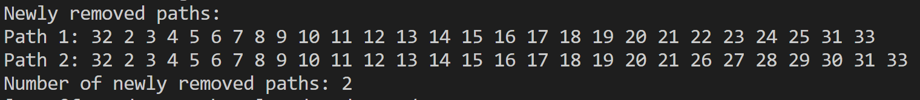

3)

Yes this change can impact the output of the code. If you run this initial version with a = .5 and b = 1, then area is calculated as -.25. In the second version, its calculated as .25.